MED D - Test Claim - Calculating Quantity of Creams, Lotions, Ointments

Definition | A topical dosage form includes:  Ointment: Generally, a smooth oily preparation that is rubbed on the skin for medicinal purposes or as a cosmetic.  Cream: Generally, a water-soluble medicinal preparation applied to the skin.  Lotion: Generally, a thick, smooth liquid preparation designed to be applied to the skin.
Instructions for Running a Test Claim | Run the Test Claim for a package size of X and a day supply of XX.  Have you used this medication?  - If yes  How long did it last?  How many grams/ounces were in the tube/container?  - If no  How many tubes/containers or ounces/grams is the prescription written?  What is the numeral after the “#” on the prescription?  How many days will you use the medication?  Note: If you are unsure what quantity is needed consult with Clinical Care Services.
Common Direction (SIG) Codes | b.i.d. - 2x/day  t.i.d. - 3x/day  q.i.d. - 4x/day  ad - up to  p.r.n. - as needed  qd - every day  qh - every hour  q4h - every 4 hours  q.o.d. - every other day
Additional Notes | - For calculations of creams and ointments, educate the beneficiary that their prescriber should indicate the size and quantity of the tube/bottle to be dispensed. Use this information to run the test claim for the appropriate package size and quantity.  - Enter the quantity in grams.  - To be as accurate as possible, the beneficiary must be able to identify the gram amount, or number of containers/tubes/ounces on the Rx so you can convert to grams.  - 1 gram = about 0.035 ounce  - 1 ounce = about 30 grams  - Dosages for creams, lotions, etc. can be difficult to determine, even for pharmacists because there are many variables.
What if Test Claim Rejects | Review the rejection code to determine what caused the rejection. Once the rejection code is identified, access the proper work instruction and job aids in  theSource to help you resolve the issue.

Example
Hydrocortisone Cream
5%

Prescription Written for: 2 – 28.35gm tubes to be applied liberally for up to 30 days
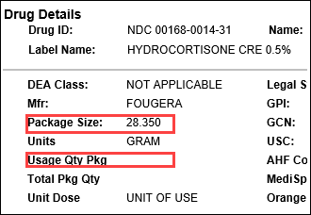 | 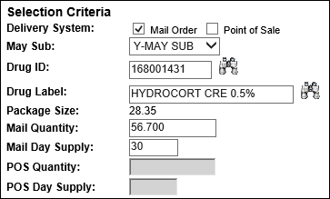
Calculation
No calculation needed. Enter quantity of 56.7 (28.35 + 28.35) for 30 day supply.

Top of the Document

Related Documents
MED D - Test Claim Index

Parent SOP: CALL-0049: Customer Care Internal and External Call Handling
Abbreviations / Definitions: Customer Care Abbreviations, Definitions, and Terms

Top of the Document

Not To Be Reproduced Or Disclosed to Others Without Prior Written Approval
ELECTRONIC DATA = OFFICIAL VERSION – PAPER COPY – INFORMATIONAL ONLY

